# Assignment 1

**Course Code: CAP 454 Set B (odd roll no.)**

**Course Title: Linux and Shell Scripting Laboratory Section: D2112**

**Name: Jayshri lal Pandit Reg. No. : 12111670**

**Roll No. : RD2112A103 Submission Date: 30 Sep.**

**Que1. Create a video which demonstrates the implementation of hard link and soft link and upload it on google drive. Write the steps for the same in a file and upload file on LPUUMS. Also include the google drive link in this file.**

**Ans: -** A *link* is an entry in your file system which connects a file name to the actual bytes of data on the disk. More than one file name can "link" to the same data.

There are two types of links:

* **Hard links:** Refer to the specific location of physical data. A hard link is a direct link to the data on disk. A hard link is a direct link to the data on disk. This means data can be accessed directly via an original filename or a hard link. Both the original file and the hard link are direct links to the data on disk. The use of a hard link allows multiple filenames to be associated with the same data on disk.

Command: - link

* **Soft Link or symbolic links or symlink**: Refer to a symbolic path indicating the abstract location of another file. A symbolic link (also sometimes known as a soft link) does not link directly to the data on disk but to another link to the data on disk. Symbolic links can link across file systems to link a folder on an external hard drive.

Command: - ln -s

**Steps of Hard links:-**

1. **Go to the RedHat Linux Desktop and take a “right click”.**
2. **Select the “New terminal” click on it after this “New terminal” open.**
3. **In root directory type “cat>>file1.txt” and press Enter and type the some text.**
4. **To view the file1 type the command “cat file1.txt”press Enter.**
5. **Hard link create “link file1.txt file2.txt”using this command and press Enter.**
6. **After this view the file2 using command “cat file2.txt” same text as having file1 will appear.**
7. **Now delete the file1 using “rm file1.txt”.**
8. **After this view the file2 here right now test is showing.**

**Steps of Soft links:-**

**1. Go to the RedHat Linux Desktop and take a “right click”.**

**2. Select the “New terminal” click on it after this “New terminal” open.**

**3. In root directory type “cat>>file3.txt” and press Enter and type the some text.**

**4. To view the file3 type the command “cat file3.txt”press Enter.**

**5. Soft link create “ln –s file3.txt file4.txt”using this command and press Enter.**

**6. After this view the file4 using command “cat file4.txt” same text as having file3 will appear.**

**7. Now delete the file1 using “rm file3.txt”.**

**8. After this view the file4 here right now test is not showing.**

**https://drive.google.com/file/d/107fI9q1cPpDQOOj9pZM9KIof8TFEqa0l/view?usp=sharing**

**Que2. Locate package nfs and vsftpd. Perform all operations of rpm on these packages. Write the steps and attach screenshots to the same file where you wrote steps of Que1.**

**Ans: -** In simple words, a RedHat package manager is a tool that allows users to install, remove, upgrade, configure and manage software packages on an operating system.

* **nfs Package**: -It stands for network file sharing. It is a protocol that allows you to share directories and files with other Linux clients over a network. Users add files to them, which are then shared with other users who have access to the folder.

**Steps for nfs package:-**

* 1. Open VMware Workstation and RedHat Linux
  2. Go to the VMware workstation “player “button click on it.
  3. Select the removable devices then CD/DVD (IDE) and select settings and click on it, a dialog box will be appear.
  4. Go to browse select ISO1 image file, check device status connected and then click on”OK” button.
  5. After this go to desktop root’s Home directory, click of “up” button click on /mnt->/cdrom->/RedHat->/RPMS/, check the nfs package and copy the path.
  6. After this open “New terminal” check nfs package install or not using the command “rpm –q nfs-utils” press Enter.
  7. If nfs package is install then firstly delete it using the command”rpm –e nfs-utils” press Enter.
  8. 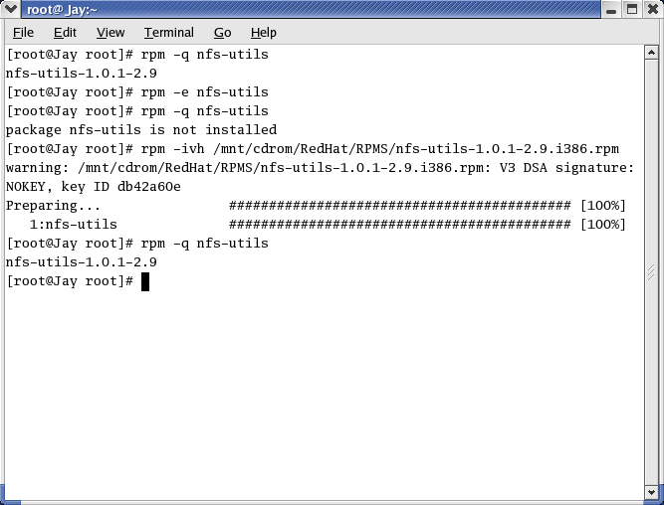After this install it using the command “rpm –ivh /mnt/cdrom/RedHat/RPMS/path of package then press Enter. After this nfs package is installed successfully.
* **vsftpd Package: - It is** stands for very secure FTP daemon. It is an FTP server for Unix-like systems, including Linux.

**Steps for vsftpd Package:-**

1. Open VMware Workstation and RedHat Linux
2. Go to the VMware workstation “player “button click on it.
3. Select the removable devices then CD/DVD (IDE) and select settings and click on it, a dialog box will be appear.
4. Go to browse select ISO3 image file, check device status connected and then click on”OK” button.
5. After this go to desktop root’s Home directory, click of “up” button click on /mnt->/cdrom->/RedHat->/RPMS/, check the vsftpd package and copy the path.
6. After this open “New terminal” check vsftpd package install or not using the command “rpm –q vsftpd” press Enter.
7. If vsftpd package is install then firstly delete it using the command”rpm –e vsftpd” press Enter.
8. After this install it using the command “rpm –ivh /mnt/cdrom/RedHat/RPMS/path of package then press Enter. After this vsftpd package is installed successfully.

